**Production System:**

The above image shows the main components of making a product.

This shows the steps in the customer getting the good/product.

Design: Product design; Process selection; Capacity planning; Facilities layout; Plant location.

Planning: Forecasting; Production planning; Materials requirement planning; Scheduling.

Control: Quality control and assurance.

**Design:** Product design; Process selection; Capacity planning; Facilities layout; Plant location.

**Planning:** Forecasting; Production planning; Materials requirement planning; Scheduling.

**Control:** Quality control and assurance.

**Topics to be Covered:**

**Inventory control:** The inventory problem; EOQ model and its extensions; Wagner-Whitin model for dynamic demand; Continuous and periodic review policies for stochastic demand; Newsvendor model for perishable items; Multi-item models.

**Supply chain management:** Supply chain concepts; Logistics and supply chain design; Multi-echelon inventory models; Risk pooling, transhipment and postponement; Bullwhip effect; Supply chain contracts; Disruption management; Reverse logistics.

**Service operations management:** Service development and delivery; Managing waiting lines; Scheduling in services; Revenue management; Service quality.

**Inventory Control**

Operations management concerns with production or service system that converts raw inputs into outputs and delivers it to the end customer. Let us restrict ourselves to the production systems. The following diagram presents a simplified view of this.

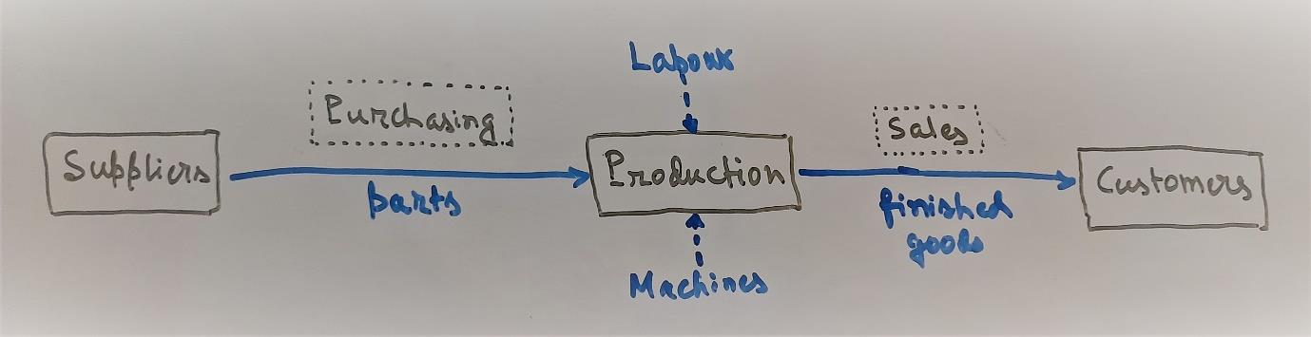

A more elaborate (and only an indicative) view is presented below.

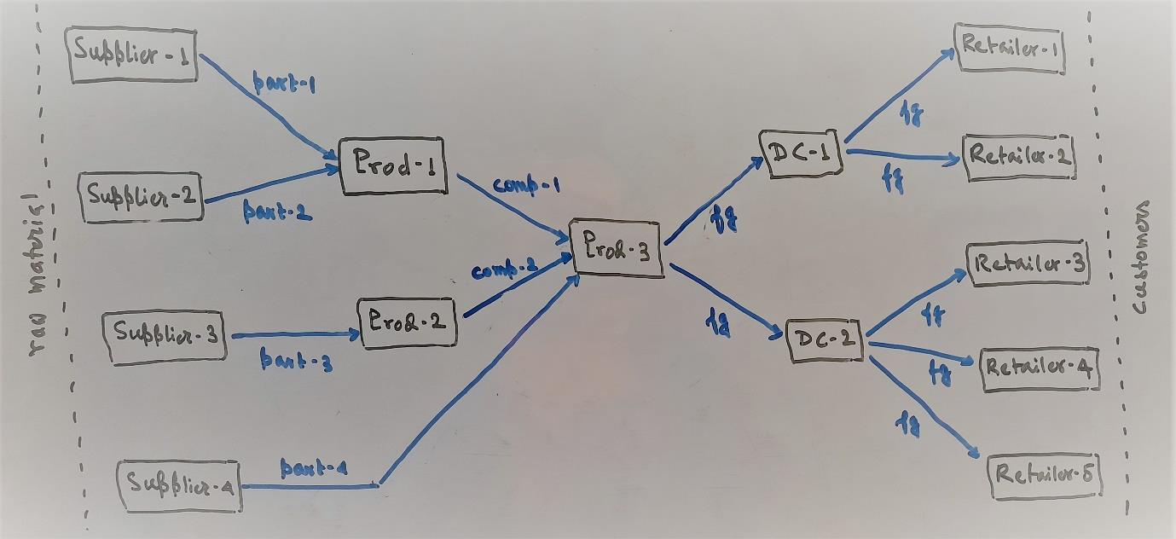

Let us consider retailers – the most downstream member in a production system. Retailers do not add value to the product, i.e., they do not transform raw materials or parts or components; they merely stock finished goods and sell these to the end customers. Same is the case with distributors, except that they supply finished goods to the retailers. Same would be the case if there are more layers in-between the manufacturer and customers.

For manufacturer and their suppliers, the situation is different. They transform raw materials or parts or components (i.e., inputs) into parts or components or finished goods (i.e., outputs). Instead of stocking, they produce outputs to meet requirements of the downstream member and accordingly procure inputs from the upstream members.

Stocking more finished goods for retailers and distributors or producing more finished goods or components or parts for manufacturers and suppliers has its advantages and costs.

**Advantages**

1. *Economies of scale*: Unit transportation cost reduces with larger procurement quantity for retailers and distributors due to economies of scale. For the same reason, unit production cost reduces with larger production quantity for manufacturers and suppliers.
2. *Lead time*: The gap between placing an order with the upstream member and receiving the supply is called the lead time. Similar gap in the production process is known as the throughput time. In order to operate during this time-lag between the requirement and its fulfillment, adequate stock must be maintained at each stage.
3. *Uncertainties*: Retailers and distributors face certain uncertainties – first and foremost the demand uncertainty, followed by uncertain lead time, and then uncertain supply quantity. Manufacturers and suppliers face uncertainty in labor, equipment, etc. in addition to the above. Holding more stock helps in mitigating these uncertainties.
4. *Speculation*: If procurement cost of raw material or parts or components or finished goods is expected to rise in future, then it makes sense to procure more than the current needs. The same is true for cost of labor, energy, etc. and production quantity.
5. *Smoothing*: Due to seasonality of demand for certain products, it may be impossible to meet the requirements in the peak season due to capacity constraints. Then it makes sense to pile up adequate stock in the lean season to meet future requirements.
6. *Decoupling*: In multi-stage production processes, it makes sense to maintain some level of work-in-progress inventory so that successive stages are decupled, i.e., a stage can run for some time during the random break-down of the previous stage.
7. *Control costs*: It is costlier to operate a system with lower level of stock as it requires careful monitoring compared to the one with higher stock level.